Cairo University  
Faculty of Computers and Information



**CS251**

**Software Engineering I**

Computek

Software Design

Mahmoud Sami

Mahmoud Amin

Mustafa Mohamed

Dec-2016

Contents

Team 3

Document Purpose and Audience 3

System Models 4

I. Class diagrams 4

II. Sequence diagrams 5

Class - Sequence Usage Table 9

Github URL………………………………………………………………………………………………………………………………………………….10

# Team

|  |  |  |  |
| --- | --- | --- | --- |
| **ID** | **Name** | **Email** | **Mobile** |
| 20140247 | Mahmoud Sami | [m.sami11111995@gmail.com](mailto:m.sami11111995@gmail.com) | 01205787165 |
| 20140271 | Mustafa Mohamed | [Mustafa_xd23@yahoo.com](mailto:Mustafa_xd23@yahoo.com) | 01280969556 |
| 20140255 | Mahmoud Amin | Mahmoudamin502@gmail.com | 01026510565 |

# Document Purpose and Audience

***Audience***

Our audience are Project manager, CEO and developers are included in our audience and anyone who have new ideas to enhance this project.

***Purpose***

This document will illustrate our efforts to develop new websites, it will also abstract the functionalities of these websites and how it will help others to learn more about specific topics, this document is purposed to stakeholders, developers and anyone interested in this project, throughout this document we will have a brief view about some definitions, requirements and use cases of all functionalities of this project.

# System Models

## I. Class diagrams

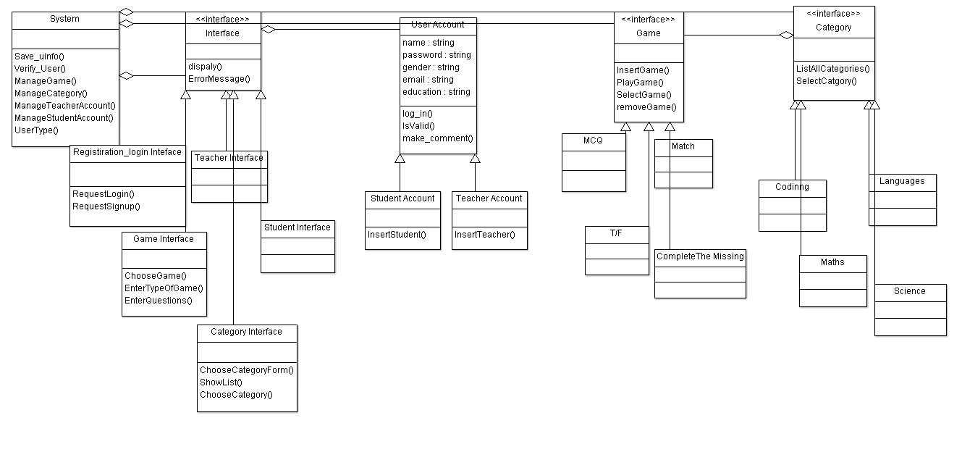

| **Class ID** | **Class Name** | **Description & Responsibility** |
| --- | --- | --- |
| S100 | System | This class is responsible for managing all other classes using manage functions. |
| UA101 | User account | Holds user’s data |
| TA102 | Teacher Account | Holds teacher’s data and responsible for inserting a new teacher in the database. |
| SA103 | Student Account | Holds student’s data and responsible for inserting a new student in the database. |
| I104 | Interface<<interface>> | Shows a friendly interface form for the user. |
| RLI105 | Registration login interface | Holds the design of the registration form. |
| TI106 | Teacher interface | Holds the design of the teacher form. |
| SI107 | Student interface | Holds the design of the student form. |
| G108 | Game<<interface>> | Holds the games data and select, insert from database. |
| MCQ109 | MCQ | A game type. |
| T/F110 | T/F | A game type. |
| M111 | Match | A game type. |
| CM112 | Complete the missing | A game type. |
| C113 | Category<<interface>> | Holds all category data & insert, select from database. |
| SC114 | Science | A category type. |
| M115 | Math | A category type. |
| LAN116 | Language | A category type. |
| C117 | Coding | A category type. |

### 

### 

## II. Sequence diagrams

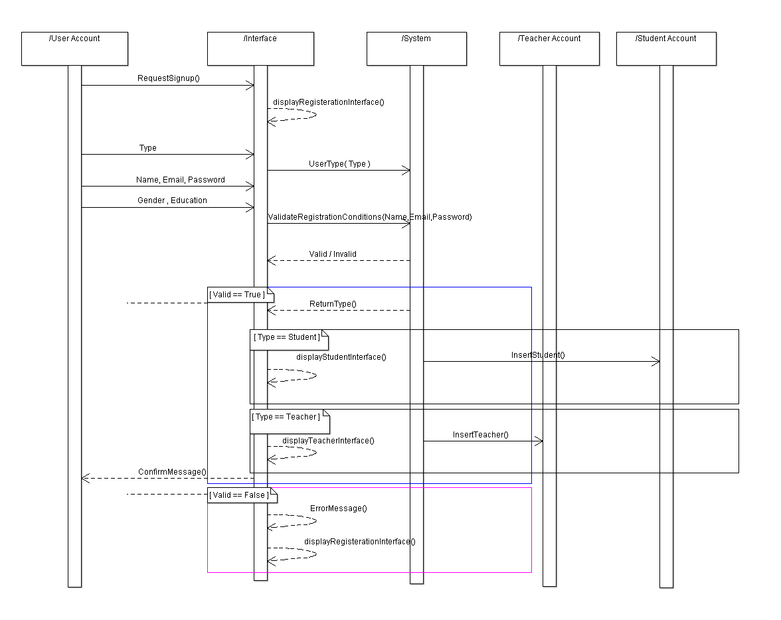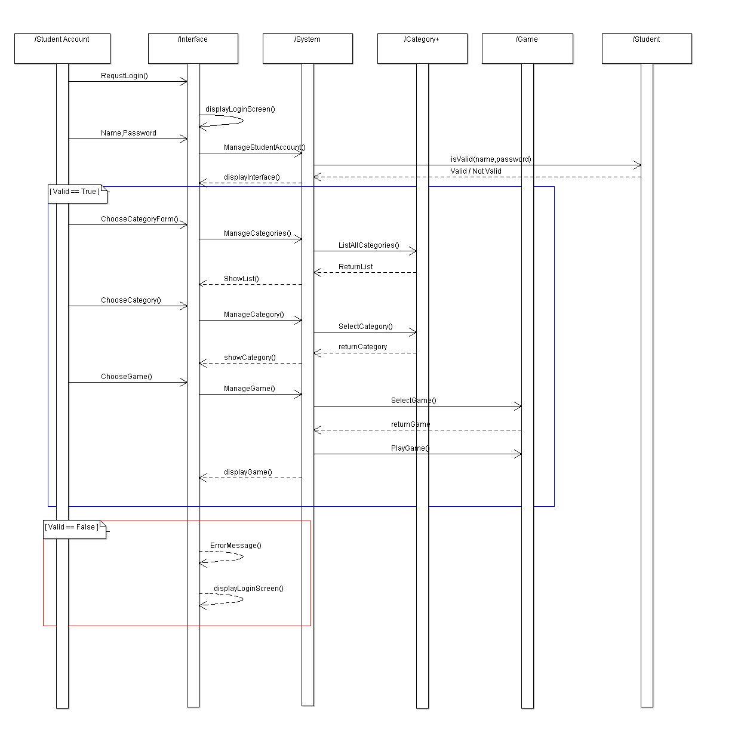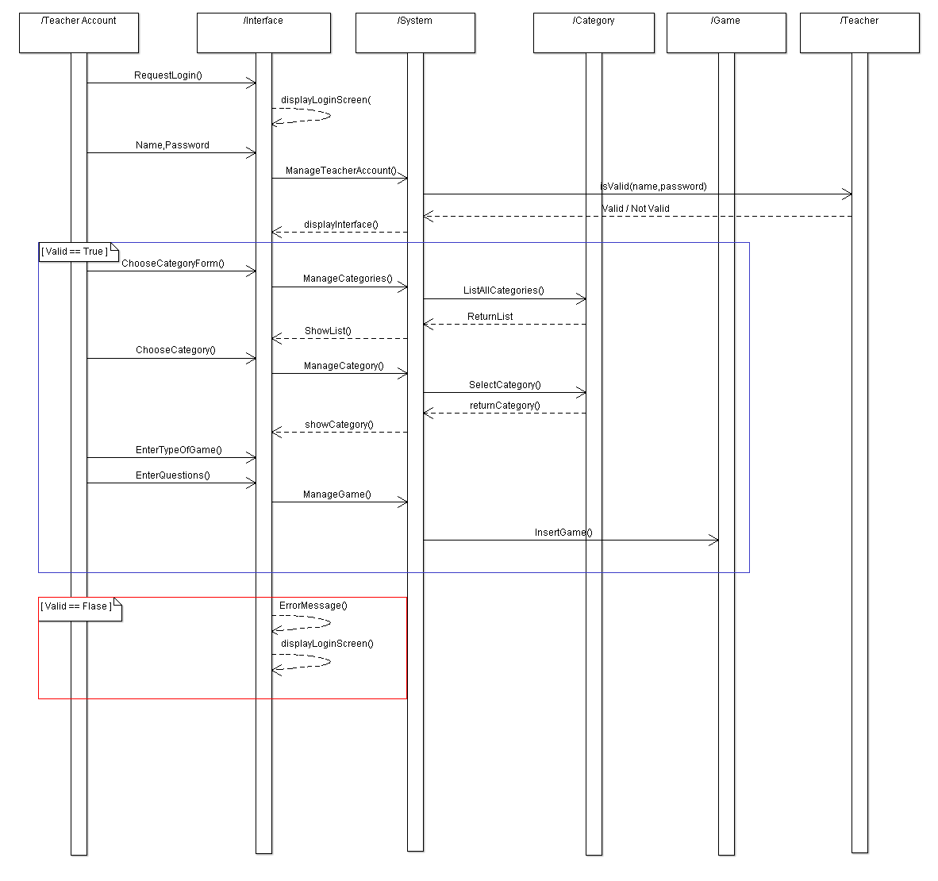

### Class - Sequence Usage Table

|  |  |  |
| --- | --- | --- |
| **Class Name** | **Sequence Diagrams** | **Overall used methods** |
| System | Add game, registration, play game. | Save_uinfo()  Verify_User()  ManageGame()  ManageCategory()  ManageTeacherAccount()  ManageStudentAccount()  UserType() |
| User account | Registration. | log_in()  isValid() |
| Teacher Account | Add game, registration. | insertTeacher() |
| Student Account | Play game, registration. | insertStusent() |
| Interface<<interface>> | Add game, registration, play game. | Display()  ErroeMessage() |
| Registration login interface | Registration. | Display()  ErroeMessage()  Requestlogin()  RequestSignup() |
| Teacher interface | Add Game | Display()  ErroeMessage() |
| Student interface | Play Game | Display()  ErroeMessage() |
| Game<<interface>> | Add Game, Play Game | insertGame()  Playgame()  selectGame() |
| MCQ | Add Game | insertGame()  Playgame()  selectGame() |
| T/F | Add Game | insertGame()  Playgame()  selectGame() |
| Match | Add Game | insertGame()  Playgame()  selectGame() |
| Complete the missing | Add Game | insertGame()  Playgame()  selectGame() |
| Category<<interface>> | Add Game, Play Game | ListAllCategories()  Selectcategory() |
| Science | Add Game, Play Game | ListAllCategories()  Selectcategory() |
| Math | Add Game, Play Game | ListAllCategories()  Selectcategory() |
| Language | Add Game, Play Game | ListAllCategories()  Selectcategory() |
| Coding | Add Game, Play Game | ListAllCategories()  Selectcategory() |

**Github URL:**